**Music supplement to Lute News 75 (October 2005)**

**The Complete Fantasias and Tocatas of Pietro Paulo Borrono (*c.*1494->1573)**

Here are collected together the six known fantasias by Pietro Paulo Borrono, found in prints published in 1536, 1546 and 1548, the latter in two distinct editions (title pages on page 21 of this supplement),[1] together with four short tocatas. The prints also include the rest of the surviving music by Borrono, comprising eighteen dance-suites, each consisting of a pavana and two or three saltarellos or other dances,[2] as well as five chansons and two motets, also most likely by Borrono although unascribed. Franco Pavan has recently argued that Borrono was responsible for collecting and editing the music for Casteliono's 1536, and probably again in conjunction with his son Giovanni Battista[3] for the 1548, print.[4] The 1536 print includes a picture (below) that may be of Borrono himself.[5] His music seems to have been known outside Italy as some found its way into lute anthologies published in Louvain, Nürnberg and Zurich.[6] Cognate versions of two fantasias as well as some dances are also found in a number of manuscripts (see worklist).

Pietro Paolo Borrono (*c*1494 to >1573) was a Milanese diplomat, soldier, music editor, composer and presumably played the lute.[7] He may have been the ‘Pierre Paul dit l’Italien’ who was a *valets de chambre* to François I king of France 1531-4 and described as superintendent of works at the royal châteaux[8] and not referred to as a musician, although this may fit with Borrono not being a professional musician but a gentleman amateur. From around 1535 he lived in the parish of S. Pietro *ad linteum* in Milan and during 1542-4 he was a diplomatic agent of Alfonso d’Avalos, imperial governor of Milan then in 1550 was a soldier of the Castello Sforzesco in Milan. In 1551 Cardinal Alessandro Farnese is recorded as accusing Borrono of organising an attempt on his (Farnese’s) life. Borrono also remained an agent of another imperial governor of Milan, Ferrante Gonzaga, until the end of 1552. Borrono and his son Giovanni Battista were mentioned in lawsuits in 1544 and 1559 and Borrono as ‘septuagenarian and infirm’ in 1564. In 1573, he was mentioned in a deed referring to his son, in a way suggesting he was still alive at the time.

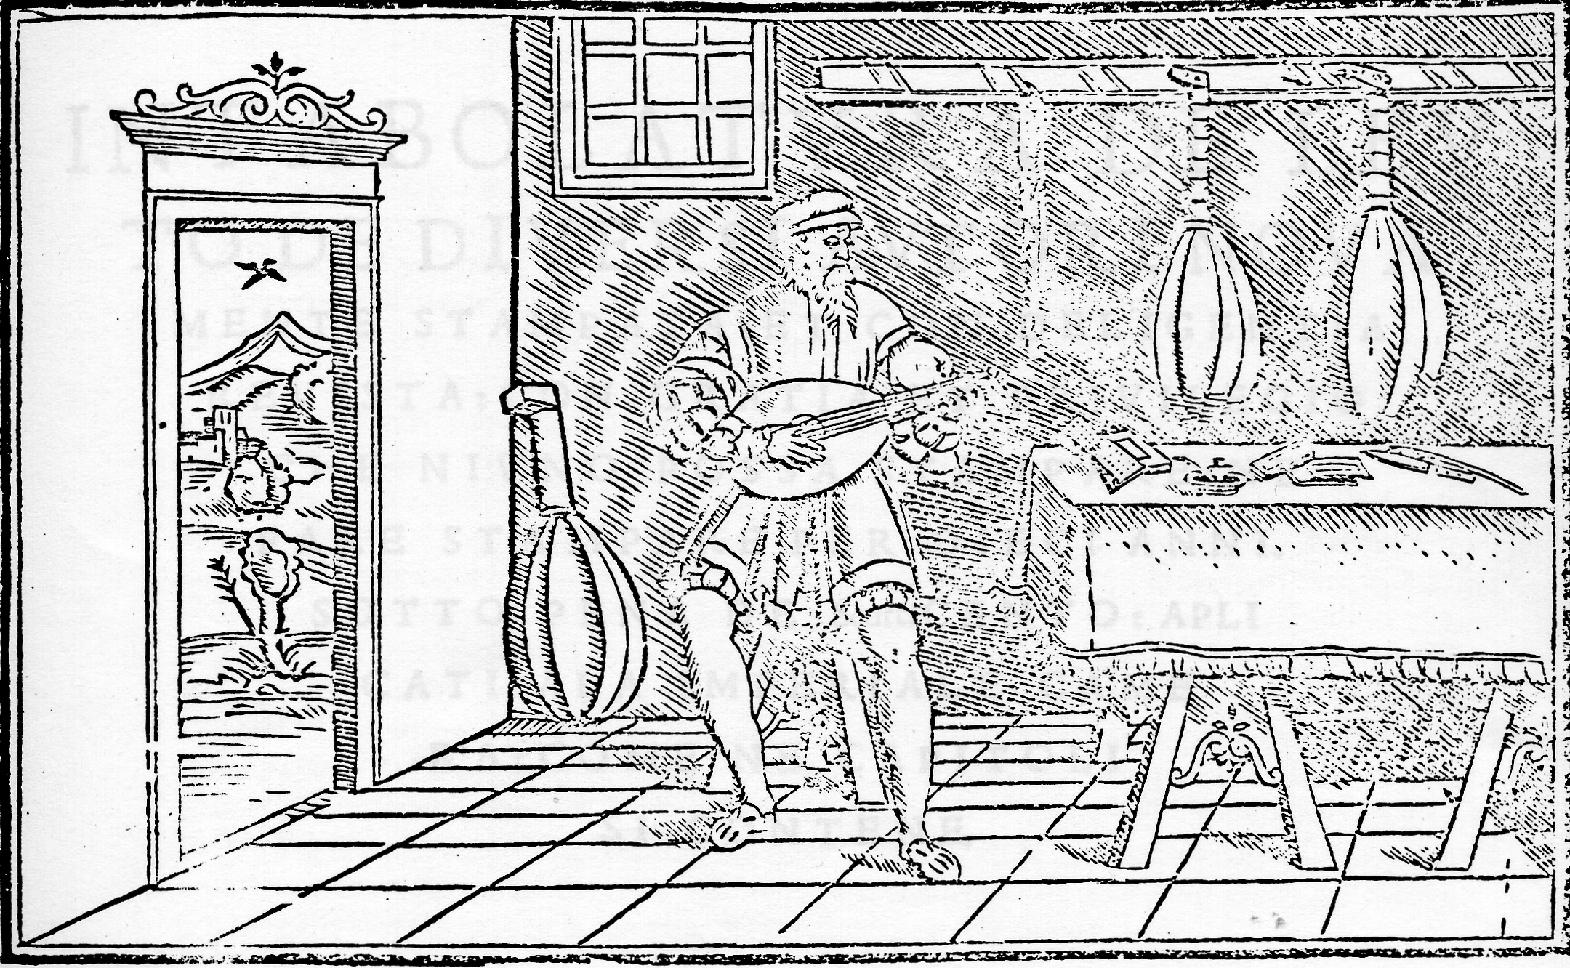

As well as six dance suites, one fantasia by Borrono (no 1a) was included in the 1536 print, and was copied into prints of Gerle and Phalèse (see worklist).[9] Two attempts of ten and thirty bars with some bars embellished are found in a fascicle dated 1560-5 in the manuscript Munich 266 and a complete version is in a different hand copied 1565-9 in the same manuscript.[10] The 30-bar fragment with some corrections from the 10-bar fragment followed by the remainder of the later version in the manuscript are included here (no 1b). The variant readings illustrate ways of embellishing the printed tablatures and could inform us how to do the same in an improvisatory manner. This fine polyphonic fantasia opens with a repeated 8-note theme which is later varied, and progresses with sections of parallel sixths and thirds and ends with an extended section of appealing broken passagework, a device that occurs in several of the fantasias and becomes a Borrono hallmark.

Three fantasias by Borrono are in the 1546 print (no 2-4), two also copied by Phalèse. No 2 is very different to the first, apart from the use of parallel thirds, and has strong affinities with music of the earlier generation of Italian lutenist composers. The repetitive rhythmic and harmonic patterns are very reminiscent of some recercars by Francesco Spinacino.[11] A curious feature of the printed version is that there are ten bars towards the end (bars 176-185) using quaver and semiquaver rhythm signs, and these ten bars are repeated at the end of the tablature with the rhythm duration doubled to make it easier to play, as the comment accompanying the extra bars in the original explains.[12] The 'easier' version has been used here, enclosed within double bar lines. No 3 sees a return to the polyphonic fantasia beginning with a repeated 12-note theme interrupted by the hint of another theme that returns at the end in a sequence so sublime that it has haunted me for the thirty years that I have been playing it - in my view this is Borrono's masterpiece. However, neither Phalèse nor other publishers chose to copy it. No 4 is found not only in the 1546 print (no 4a), but also in an embellished version in a later manuscript[13] (no 4b) and is another polyphonic fantasia beginning with a theme which is then repeated sequentially a major second, an octave and a major ninth lower. Broken passagework follows and the fantasia ends with an appealing sequence of descending suspensions and then a cascade of descending parallel thirds. The theme is a major key variant of the first seven notes of the opening of a recercar of Vincenzo Capirola,[14] which together with the early reanaissance form of no 2, may be a link to the earlier generation of lutenist composers.

The final two fantasias are in both of the 1548 prints, and were not copied in prints outside Italy. No 5 (the tablature out of sequence here to fit on the pages) is another in an early recercar style and is dominated by ascending and descending scalic passages, extending up to high fret positions (n). No 6 is the final polyphonic fantasia, opening with an 8-note theme repeated and varied for some time before an extended section of scalic passages over a wandering bass with some attractive broken passagework and then ending with a slower 19-bar coda and final cadence. This is the only item that needed some reconstruction, because of a rhythmic peculiarity present in the opening theme and elsewhere (bars 1, 3, 5, 6, 7, 28, 32 & 39) in both printed versions. In each case, the prints have a dotted minim followed by a semibreve, which doesn't make rhythmic sense and so the semibreves have been replaced here by crotchets. In addition, bars 63-7 required reconstruction of rhythm to correct what seem like obvious printers errors in the rhythm signs, although the result is not entirely satisfactory.

Four short items titled tocata each follow a dance suite in the 1536 print. Only the first dance, the pavana, in each suite in the 1536 print is ascribed to Borrono, so it is assumed that the whole dance suites of pavana, saltarellos and tocata are composed by him. However, although two tocatas are not directly ascribed, one bears the initials 'p.p.b.' on the contents page, and another is ascribed to Francesco da Milano in the title. So presumably Francesco contributed one, and the other three were by Borrono (tocatas 1-3 here). The Scotto 1546 and Castilliono 1548 prints include a single page of instructions on how to read tablature[15] (the 1548 version reproduced on page 3 here), including an example of what is probably another tocata (tocata 4 here). It is not ascribed but it is included as likely to be by Borrono.

**Worklist** Minor editorial changes made without comment.

**Fantasias**

1a. Casteliono 1536, ff. 33r-34v *Fantasia di.M.Petro Paulo da Milano*

Gerle 1552, sig. H2 *Das 24. Preambel Petter Paul von*

*Mailandt / Peter paul de Milano*

Phalèse 1552, p. 18 *Fantasia* [*Pauli Baroni*]

Phalèse 1563, f. 5v *Fantasia Pauli Baroni*

Scotto 1563, p. 14 *Fantasia di P. Pa. Borono da Milano*

Phalèse 1568, f. 2v *Fantasia Pauli Baroni*

Phalèse 1571, f. 1v *Fantasia Pauli Baroni*

1b. D-Mbs 266, ff. 73r [untitled, first 30 bars only]

D-Mbs 266, ff. 72v [untitled, first 10 bars only]

D-Mbs 266, f. 106r *Fantasia de Petro Paul de Milano*

2. Scotto 1546, f. 28r *Fantesia dell’Eccellente P.P.Borrono da Milano/ Fantesia dell’Eccellente Pietro Paulo Borrono da Milano*

Phalèse 1546, sig. bb1v *Fantasia de Petro Paulo da Milano*

Phalèse 1552, p. 12 *Fantasia* [*Pauli Baroni*]

Phalèse 1563, f. 1v *Fantasia Pauli Baroni*

3. Scotto 1546, f. 31v *Fantesia dell’Eccellente P.Paulo Borrono da Milano/ Fantesia dell’Eccellente. Pietro Paulo Borrono da Milano*

4a. Scotto 1546, f. 33r *Fantesia dell’Eccellente P.Paulo Borrono da Milano/ Fantesia dell’Eccellente. Pietro Paulo Borrono da Milano*

Phalèse 1546, sig. bb4v *Fantasie de Pierre Paule Barron*

4b. D-DO G.I.4 III, ff. 9v-10r *Phantasia Pauly Borrono da Milano*

5 Scotto 1548, sig. G1v *Fantasia di P.Paulo Borrono*

Castilliono 1548, ff. 28v-29r *Fantasia*

*dell’Eccelente. P.P.Borono da Milano*

Scotto 1563, p. 44 *Fantasia di P. Pa. Borono*

6 Scotto 1548, sig. G4v *Fantasia di P.Paulo Borrono*

Castilliono 1548, ff. 31v-32v *Fantasia dell’Eccelente.P.Paulo Borono da Milano*

**Toccatas**

1. Castiliono 1536, f. 13v *Tochata da sonare nel fin del*

*ballo/Tochata nel fin del ballo*

2. Castiliono 1536, f. 17v *Tochata nel fine del Ballo*

3 Castiliono 1536, f. 53v *Thocata /Tocata p.p.b.*

4 Scotto 1546, f. 1r [Regola example - tocata?]

Castilliono 1548, f. 2r [Regola example - tocata?

*John H Robinson, Newcastle University, August 2005*

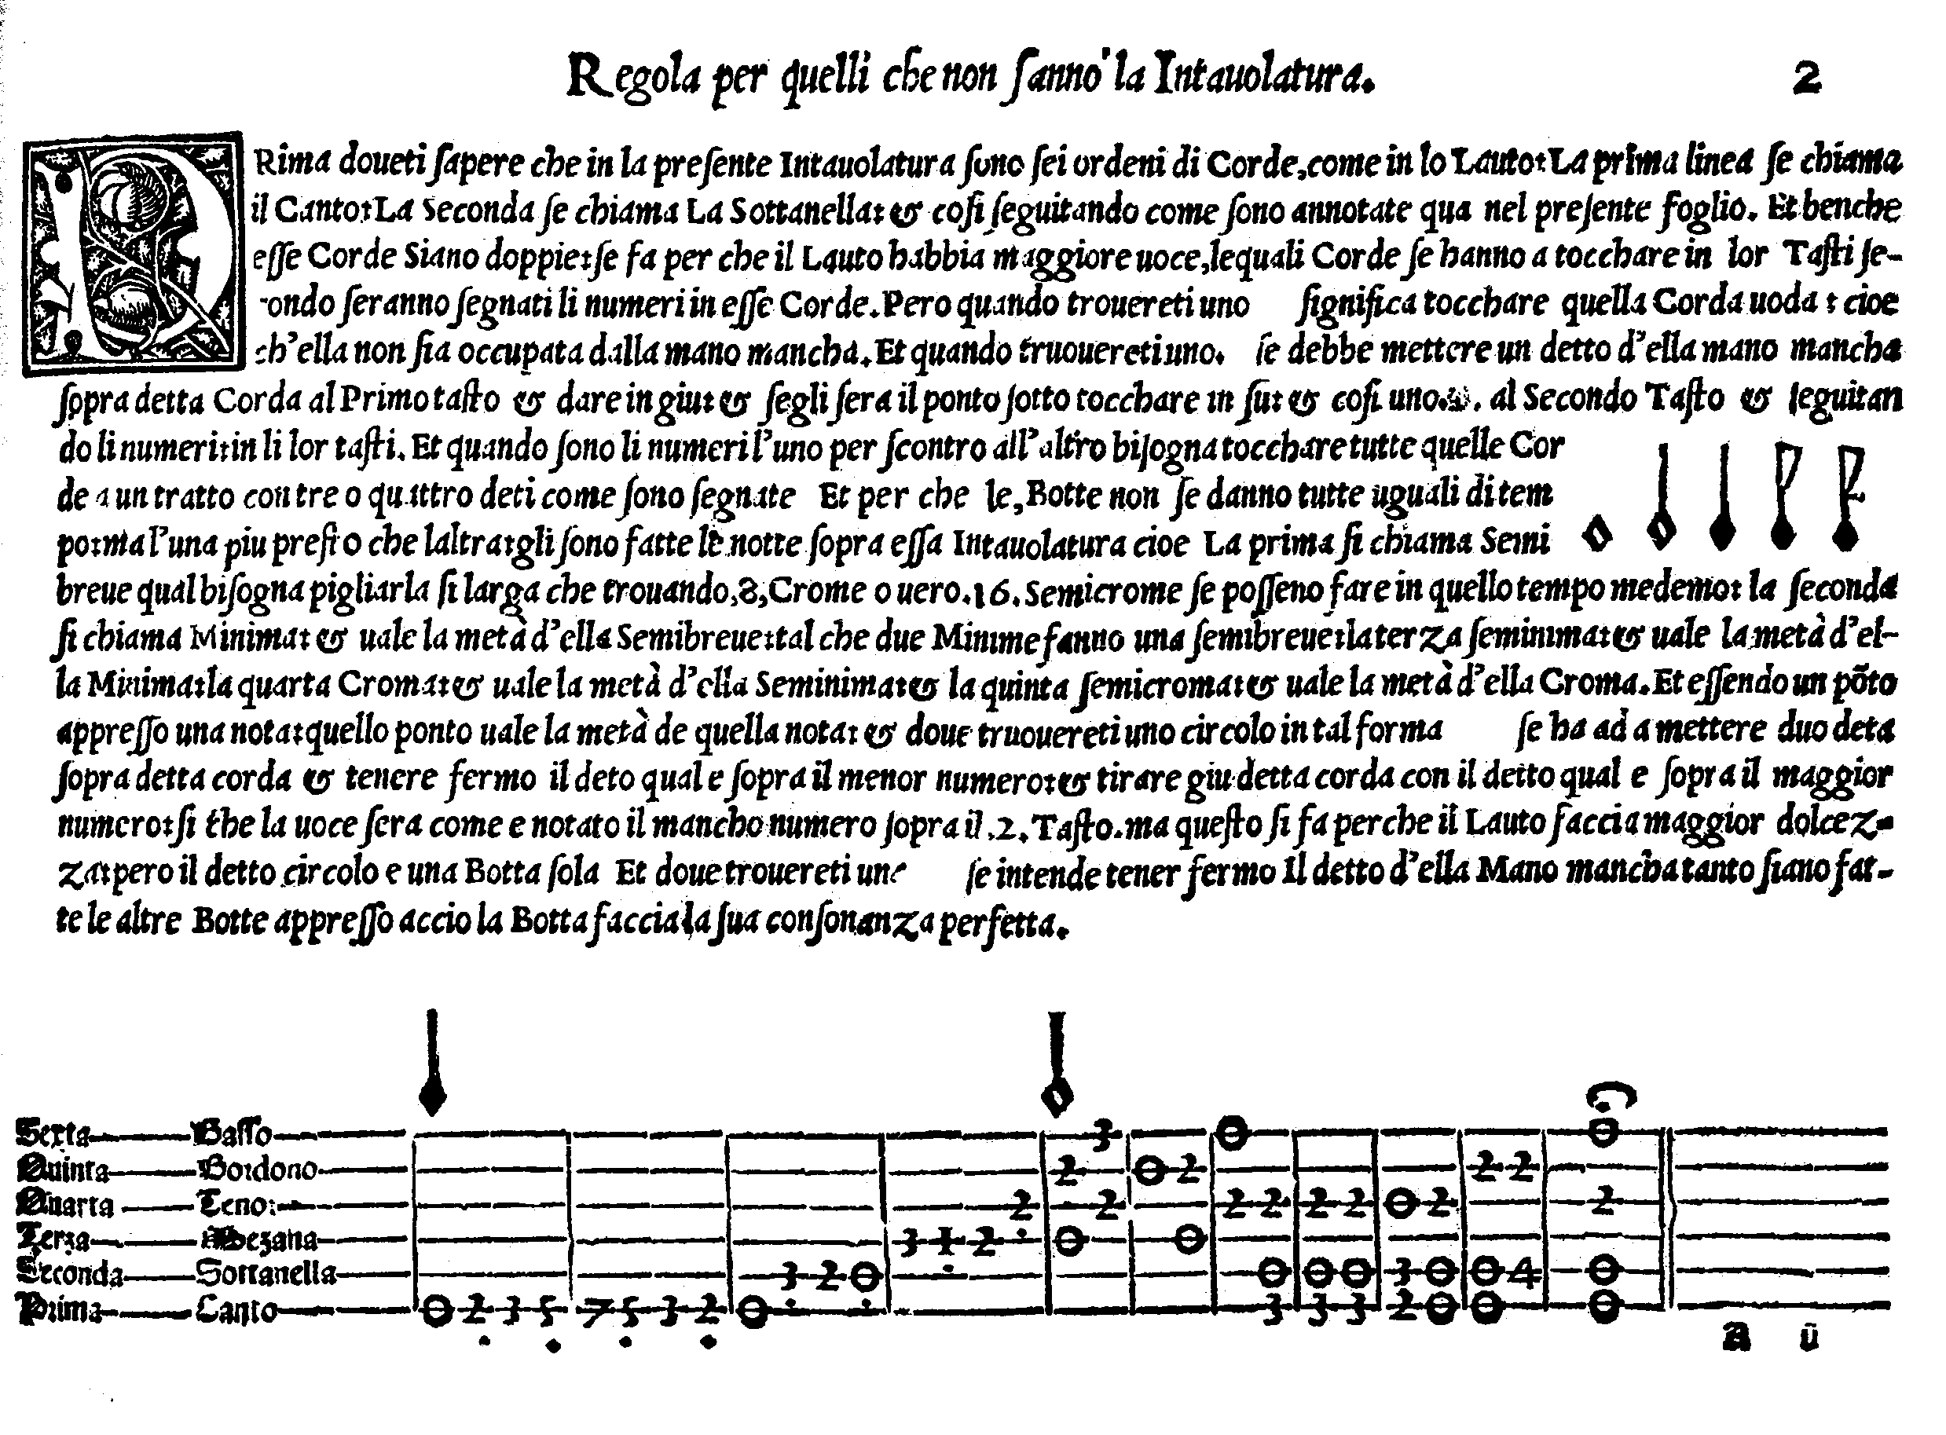

Title page from *Castilliono* 1548

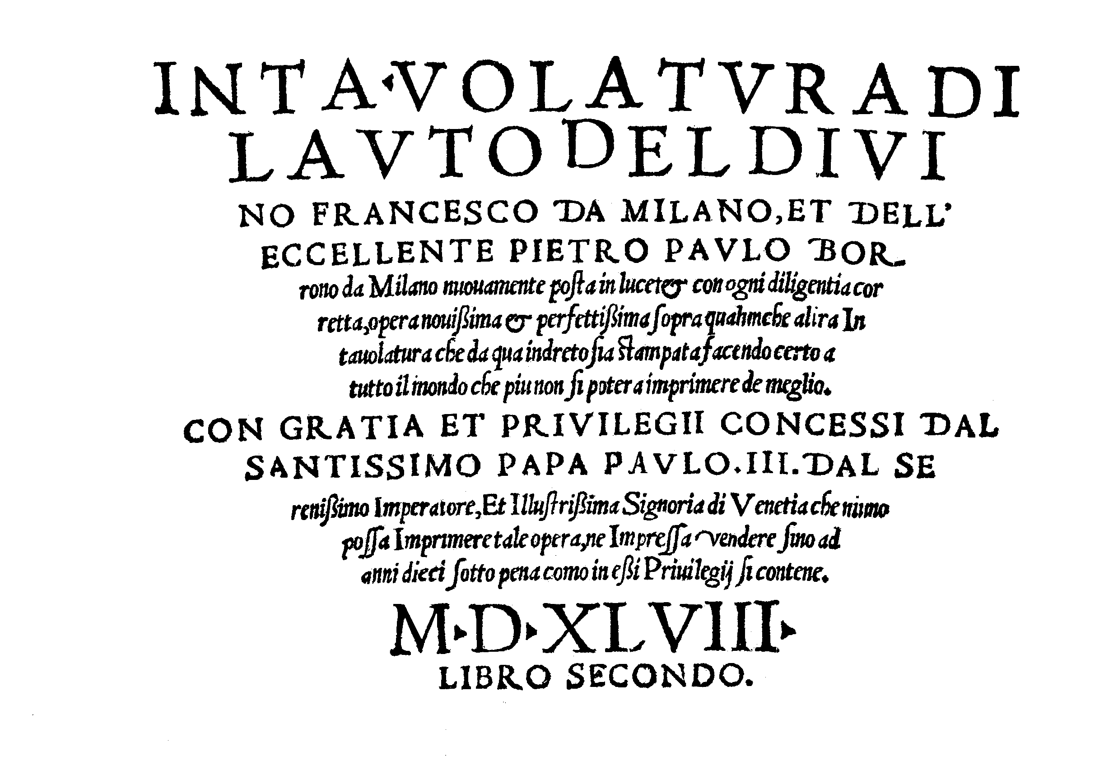

Title page from *Scotto* 1548

Title page from *Casteliono* 1536

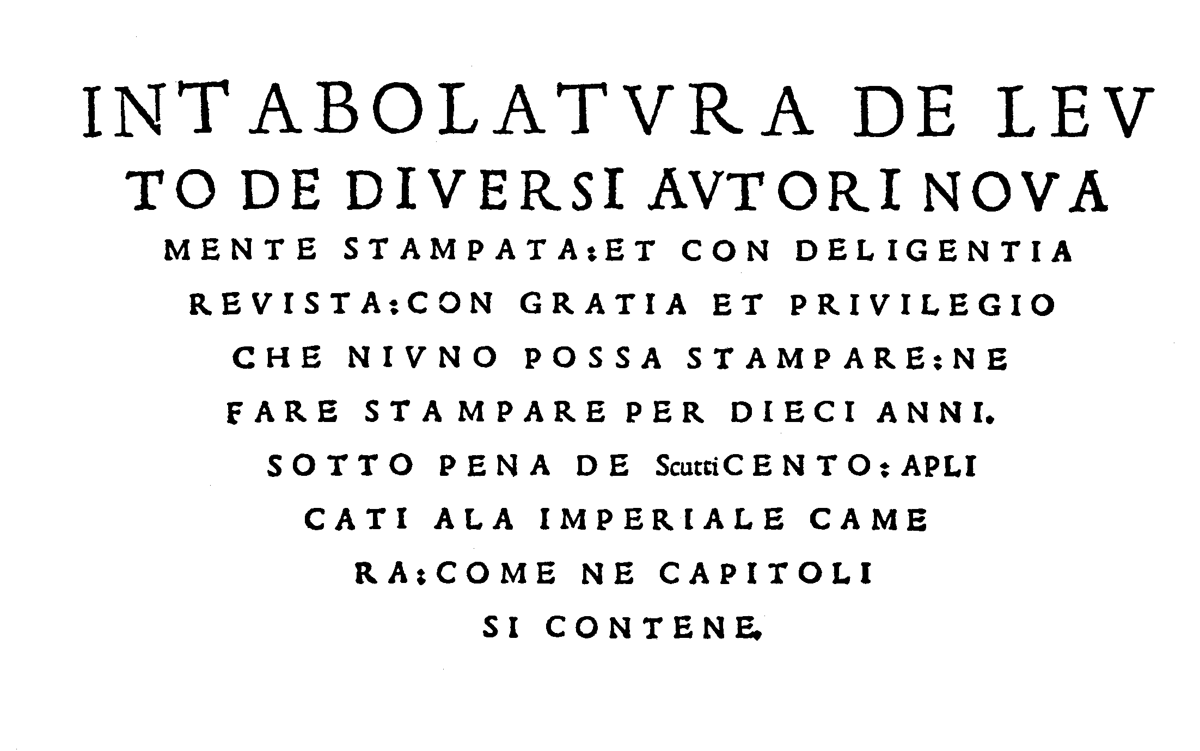

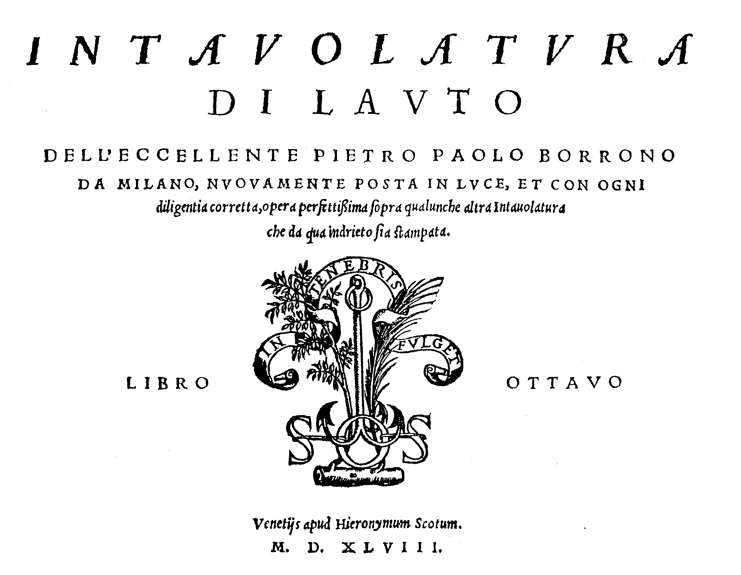

Title page from *Scotto* 1546

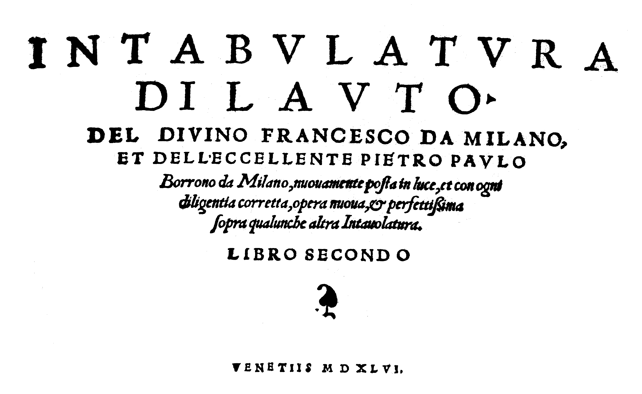

1. The three printed sources: **1.** *Intabolatura de Lauto de diversi autori* published by Giovanni Antonio Casteliono [Castiglione] in *Milano*, 1536 [copies in Firenze, Paris and Wien, the latter used for the facsimile edition by Orlando Christoforetti (Firenze: SPES, 1979)], includes a fantasia, six dance suites, some with tocatas, by Borrono and fantasias by Francesco da Milano, Alberto da Mantua (Albert d'Rippe), Marco da Laquila and Jo. Jacobo Albutio da Milano, partial contents also published under the same title by Scotto in *Vinegia* in 1563 (copies in Washington and Wien). **2.** *Intabulatura di Lauto di divino Francesco da Milano et dell'eccellente Pietro Paulo Borrono da Milano, Libro Secondo*, probably published by Scotto, in *Venetiis* in 1546 [only copy in Uppsala], includes three fantasias and six more dance suites by Borrono. Franco Pavan speculates that this is a copy of a now missing edition published by Casteliono in Milan. **3.** *Intavolatura di Lauto del Divino Francesco da Milano et dell'eccellente Pietro Paulo Borrono da Milano, Libro Secondo*, [on last page:] *Stampato nella Inclita Citta de Milano per Gio. Antonio da Castilliono* [Castiglione] *ad Instantia de M. Gio. Bap. Borrono* [i.e. printed by Castiglione and dedicated and published by Borrono’s son Giovanni Battista], in 1548 [only copy in Paris, used for the facsimile edition by Franco Pavan (Bologna: Forni, 2002)] including two fantasias and four suites by Borrono; the latter print contains the same music as *Intavolatura di Lauto dell'eccellente Pietro Paulo Borrono da Milano, Libro Octavo*, published by Scotto in *Venetiis* in 1548 [only copy in Venezia, and available in modern Italian tablature edition encoded in Stringwalker from Alain Veylit's website in a complete page-by-page reconstruction], and partially reprinted under the same title by Scotto in *Vinegia* in 1563 (copies in Washington and Wien). Fantasia 1 and Tocata 3 can also be found in Lute Society tablature sheet C6.
2. The complete seventh suite, from the 1546 print is in 'Renaissance Dances Part II', tablature supplement to *Lute News* 72 (December 2004), no 39.
3. Could he be the Giovanni Battista to whom three lute solos are ascribed in the Barbarino lute book?: **1.** PL-Kj 40032, p. 75, *Di Gio: B:* = DL-Hgm 28 B 39 (Siena), f. 72r, *Fantasia*; **2.** PL-Kj 40032, p. 117, *Passagio di giovani Batista / dirata di finale*; **3.** PL-Kj 40032, p. 169, *Pass’emezzi di Gio: Batta*.
4. See also introduction by Franco Pavan to Forni facsimile of the 1548 print referred to in footnote 1.
5. The picture is distorted as the lute in the corner as well as the figure himself look huge compared to the doorway.
6. Rudolph Wyssenbach, *Tabulaturbüch uff die Lutten* (*Züryck*, 1550/facsimile, Lübeck: Tree Editions, 1999); Hans Gerle, *Newes sehrs Künstlichs Lautenbuch* (*Nürnberg*, 1552/ facsimile, Stuttgart: Cornetto-Verlag, 1997); and, all published in *Lovanni* by Pierre Phalèse: *Carminum pro Testudine Liber IIII* (1546), *Hortus Musarum* (1552/facsimile, Bruxelles, Office Inter-nationale de Librairie, undated), *Theatrum Musicum* (1563), *Luculentum Theatrum Musicum* (1568/facsimile, Genève: Minkoff, 1983) and *Theatrum Musicum* *Longe* (1571/facsimile, Genève: Minkoff, 2002).
7. See 'Borrono, Pietro Paulo', Jeanette B. Holland and Arthur J. Ness, *New Grove II*.
8. Two of which, Chenonceau and Amboise, I visited in July 2005.
9. Fantasia no 1a together with 14 of Borrono's dance movements were recorded by Joachim Held, *I Grandi Liutisti Milanesi del Cinquecento: Francesco da Milano, Pietro Paulo Borrono, Giovan Paolo Paladino* (Symphonia SY 95144, 1996).
10. München, Bayerische Staatsbibliothek [D-Mbs], Mus. Ms. 266, *c*1550-70.
11. For example Francesco Spinacino, *Intabulatura de Lauto Libro Primo* (Venetiis: Petrucci, 1507/facsimile: Genève, Minkoff Éditions, 1978/R1992), ff. 51r-52r, *Recercare 15*, and edited in 'Twenty four preludes and recercars from the early renaissance', tablature supplement to *Lute News* 68 (December 2003), no 6.
12. It reads: 'Per che ne la detta fantesia li sono alchune battute che alli scholari serano dificile glie fatte le medeme battute in altra forma di tempo piu facile cioe se redotta la semicroma in croma. Et la croma in semi-nima. Et accio se cognosca doue se hanno a fare glie stato fatto uno tal segno.' kindly translated by Paul Beier and Mariagrazia Carlone as: 'Since in the said fantasia there are some measures that will be difficult for students, the same measures were made with another, easier, form of rhythm. That is: the semiquaver has been transformed to quaver, and the quaver to crotchet. And in order to recognize where they are, a sign ... has been placed.
13. Donaueschingen, Fürstlich Fürstenbergische Hofbibliothek [D-DO], Ms. G.I.4, *c*1580-95.
14. See Chicago, Newberry Library, Special Collections, Ms. Lute Codex Vincenzo Capirola, *Compositione di meser Vicenzo Capirola gentil homo bresano*, *c.*1517, pp. 10-2 [facsimile edition with introduction by Orlando Christoforetti (Florence: SPES, 1981)] and edited in 'Twenty four preludes and recercars from the early renaissance', tablature supplement to *Lute News* 68 (December 2003), no 23.
15. Instructions from Castilliono 1548 kindly translated from the Italian by Paul Beier and Mariagrazia Carlone (the text in bold, describing how to finger an upper appogiatura as notated in the dances but not fantasias in the 1548 print, is not in the 1546 edition but was added for the 1548 edition) as: 'Rules for those who don't know tablature. First you must know that in the present tablature there are six courses just as on the lute: the first line is called "Il Canto": the second is called "La Sottanella": and so on as they are notated here on the present page (see below). And these strings are double: this is done so that the Lute has a bigger voice. The said strings must be stopped on their frets according to how the numbers are notated on those Strings. Thus, when you find an "0", this means to play that string open: that is, it is not stopped with the left hand. And when you find a "1" you must put a finger of the left hand over that string on the first fret and pluck it downwards, and if there is a dot underneath it, pluck it upwards. And likewise: a "2" on the second fret and the following numbers on their frets. And when the numbers are one above the other, you must play all those strings together with three or four fingers as notated. And since the plucked notes are not played all in the same rhythm, but one faster than another, notes are placed above the tablature. That is, the first is called "semibreve", which one must play so slowly that, finding eight "crome" or sixteen "semicrome", these can be played in the same span of time. The second is called "minima" and is worth one half of the semibreve, so that two minime make a semibreve. The third is a "seminima" and is worth one half of a minima. The fourth is a "croma" and is worth one half of a Semiminima. And the fifth is a "semicroma" and is worth one half of a croma. And if there is a dot after a note, that dot is worth half of the note. **And where you find a circle in this form** [?]**, one must put two fingers over that string, and hold down the finger that is over the lesser number, and pull down the string with the finger that is on the greater number. In this way the resulting sound will be that notated with the lesser number, [for example] on the second fret; but this is done so that the lute produces more sweetness: however the said circle is [played with] a single [right hand] stroke.** And where you find (double cross) this means to hold down the finger of the left hand while the following strokes are played so that the note makes its perfect consonance [with the following notes].’ I have reproduced the tenuto signs [for holding notes] as in the original but with a single rather than double cross after the tablature letter.